Power BI Assignment 1 – Data Transformation & Data Modeling
RESHMA V M
Power BI is a business intelligence and data visualization tool developed by Microsoft. It helps users collect, analyze, and visualize data from different sources. Power BI allows users to create interactive, dashboards reports, charts, and graphs that make complex data easier to understand.
Import data:
- Import “List of Orders.csv” into Power BI & Open “List of Orders” in Power Query Editor by clicking on ‘Transform’.
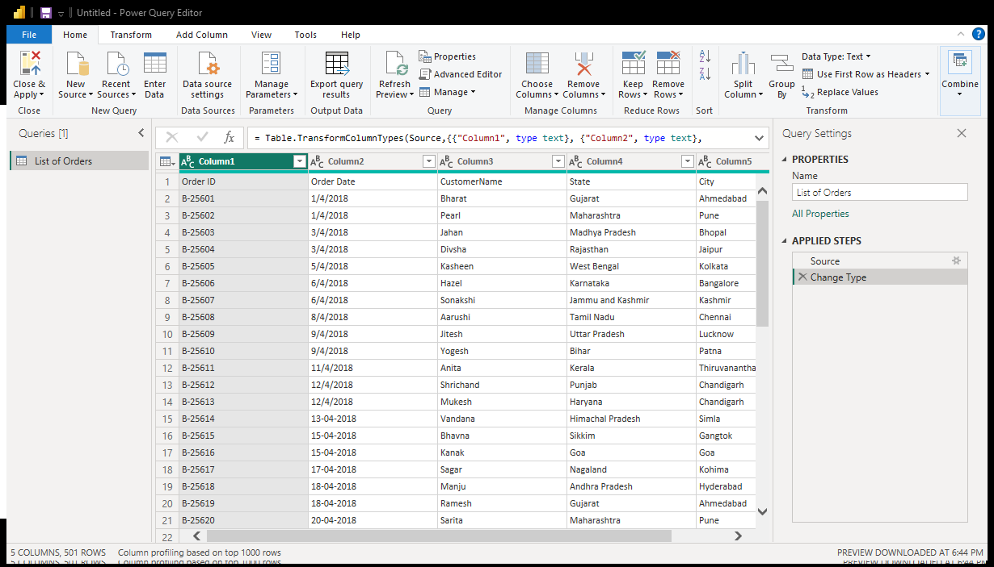
The List of Orders.csv file can be imported into Power BI by opening Power BI Desktop, selecting Get Data → Text/CSV, choosing the file, and clicking Load. Power BI will automatically detect the data structure and display a preview of the available columns and records. After reviewing the data, the Load option imports the dataset into Power BI.

Pic: “List of Orders” in Power Query Editor by clicking on ‘Transform’
- Import “Order Details.csv” and “Sales target.csv” into Power Query Editor.
- Open Power BI Desktop.
- Click Get Data and select Text/CSV.
- Choose Order Details.csv and click Transform Data.
- The file will open in Power Query Editor.
- Repeat the same steps for Sales target.csv.
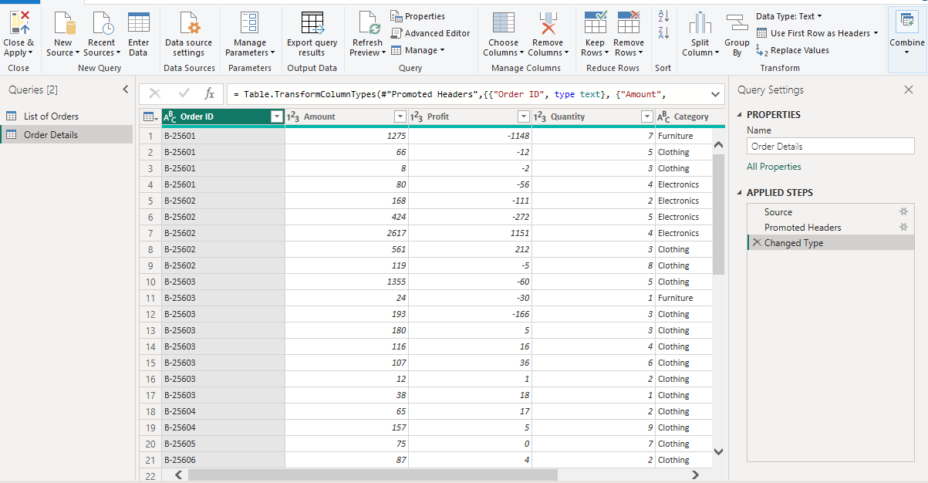
- Both files will now be available in Power Query Editor.
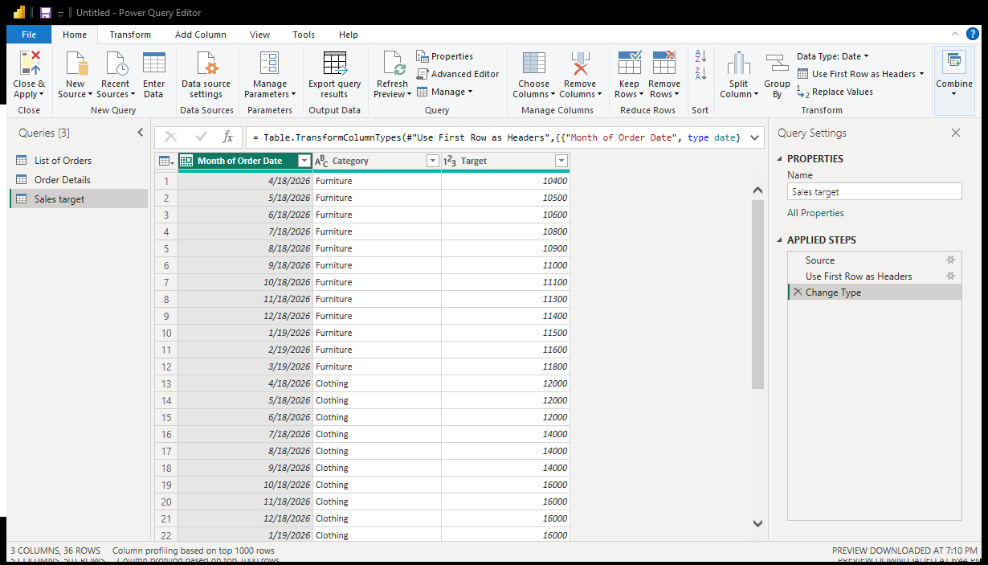
Pic: “Order Details.csv” in Power Query Editor by clicking on ‘Transform’
Pic: “Sales target.csv” in Power Query Editor by clicking on ‘Transform’
Data Transformation:
- Restrict the "List of Orders" table to only the first 500 rows.
In Power Query Editor, first select the “List of Orders” table. Then go to the Home tab and click Keep Rows. Select Keep Top Rows and enter 500 in the box. Finally, click OK. This will keep only the first 500 rows of the List of Orders table.

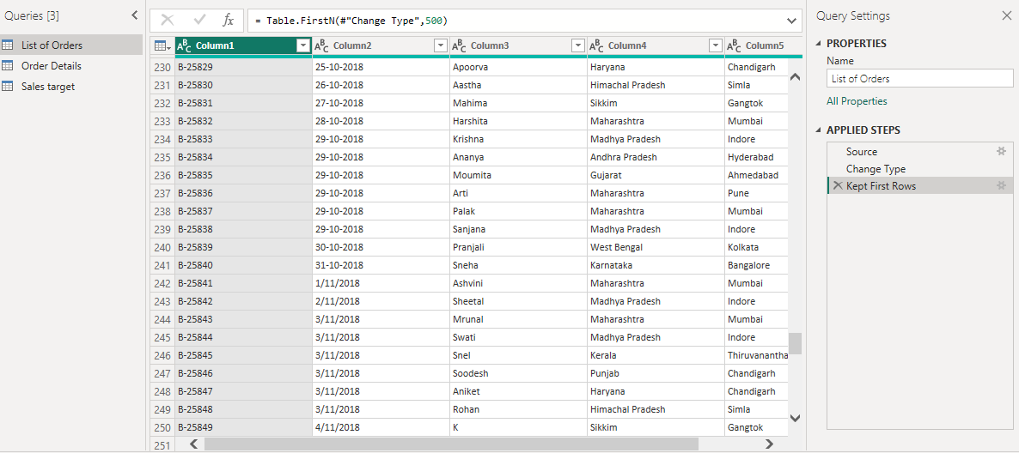

- Ensure the “Order Date” column in the “List of Orders” table is set to data type 'Date'
Initially, I changed the column names Order ID, Order Date, Customer Name, State, and City to serve as the headers. To do this, I went to Home → Use First Row as Headers. This option takes the values from the first row of the data and sets them as the column headers.
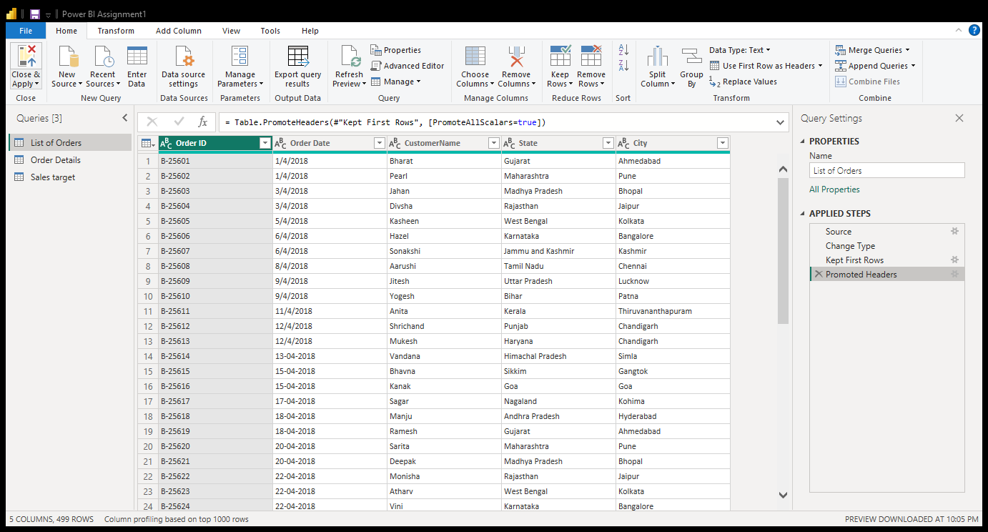
Pic: Promoted Headers
The Order Date column initially showed errors when I changed its data type to Date. To fix this, I used Change Type → Using Locale, selected Date as the data type and Malayalam (India) as the locale, then clicked OK. This successfully converted the Order Date values into the correct date format.
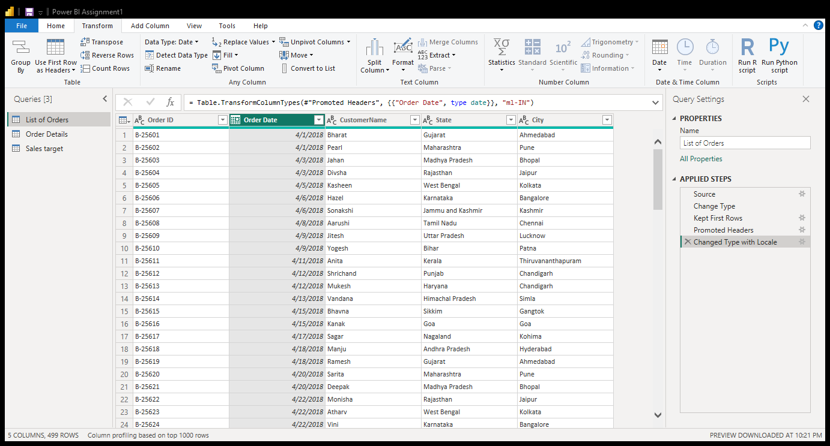
Pic: Changed data type column(Order date)

- Change the data type of “Amount” and “Target” columns to ‘Fixed Decimal Number’.
I selected the Amount and Target columns and changed their data type to Fixed Decimal Number to ensure the values are displayed accurately with decimal precision.

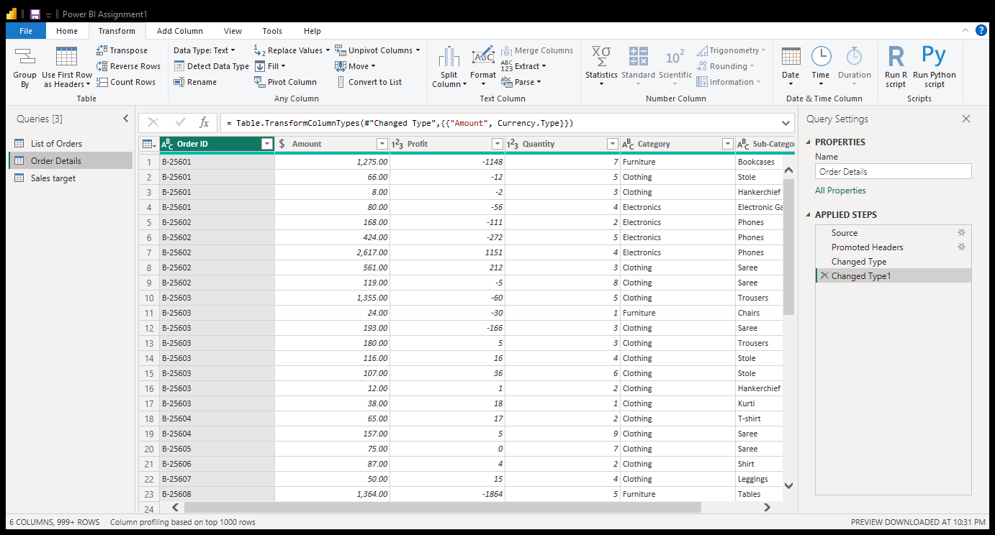
Pic: Amount data type changed into Fixed Decimal Number
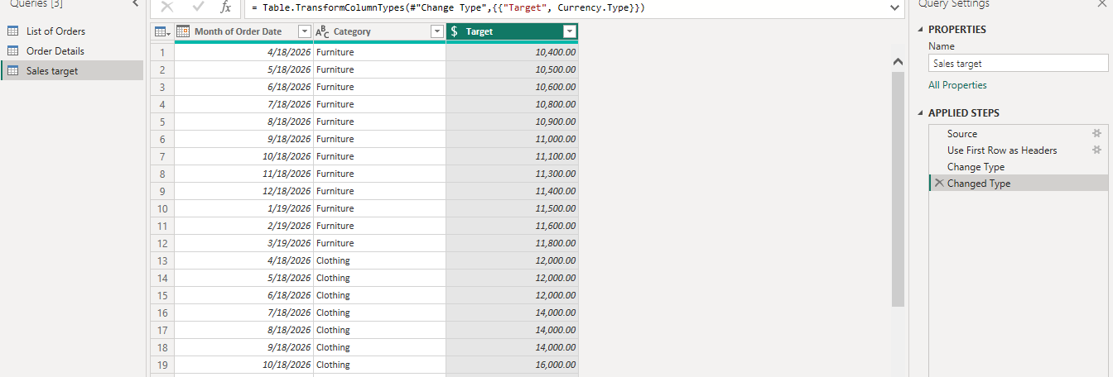
Pic: Target data type changed into Fixed Decimal Data type

- Format the "CustomerName" column into proper case, ensuring consistent capitalization for each word.
- Select the CustomerName column.
- Go to Transform → Format → Capitalize Each Word.
This changes each customer name to Proper Case, ensuring consistent capitalization for every word.
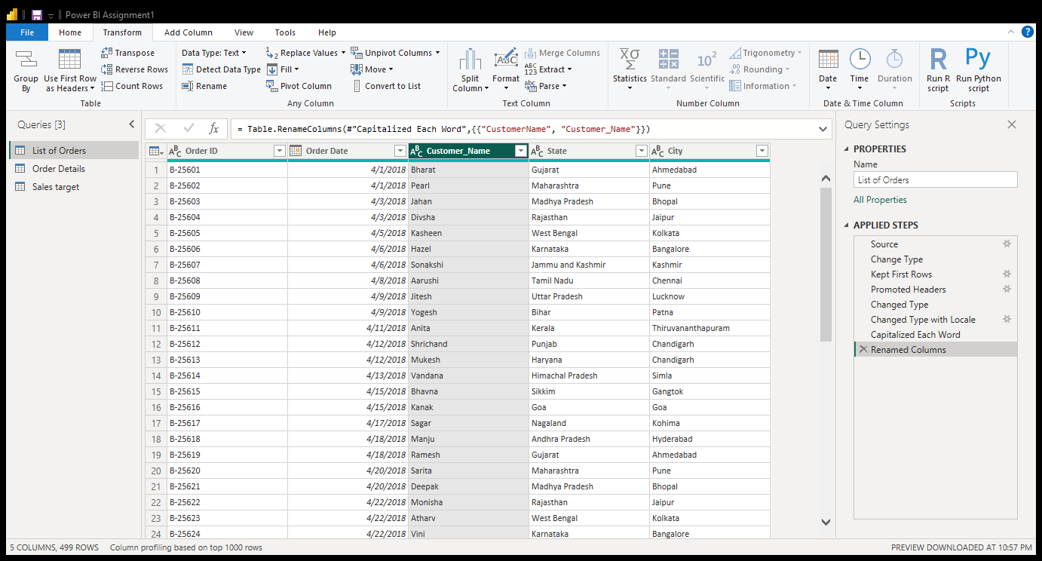
Pic : Capitalized Customer_Name column
- Merge the "State" and "City" columns to create a new column named "Location" in the format ‘City, State’.
- Select the City and State columns.
- Go to Transform → Merge Columns.
- Select Comma as the separator.
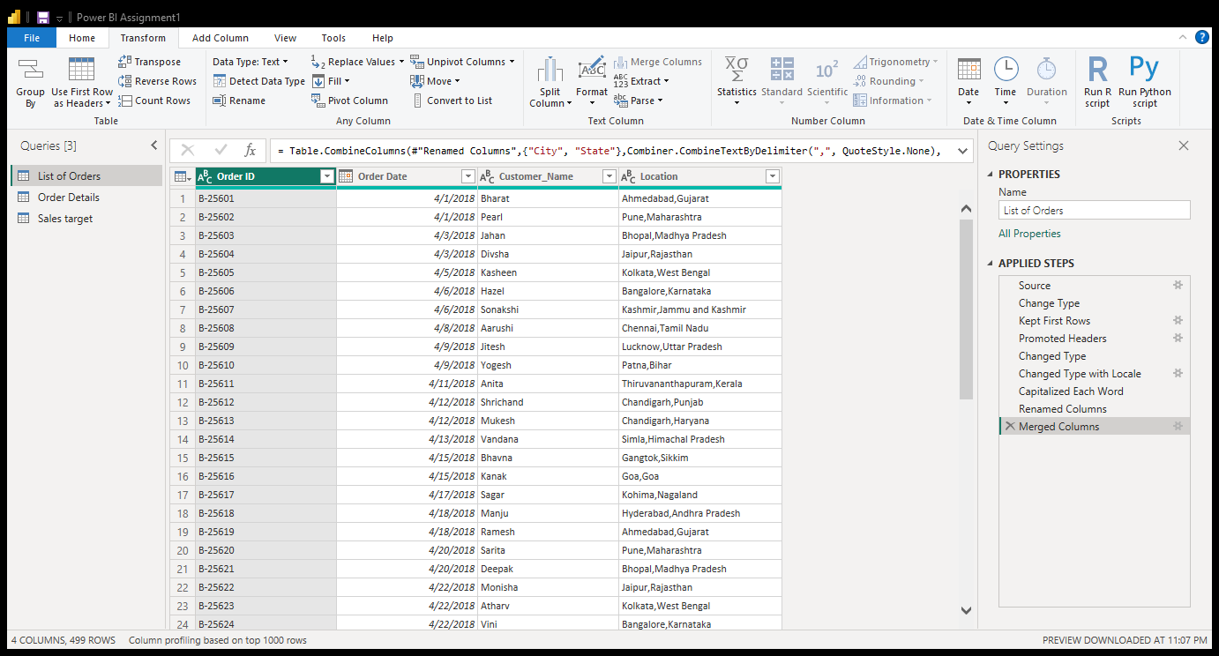
- Enter Location as the new column name. Click OK.
Pic: Merged column Location(Merged State & City )

- Create a new custom column named "Profit Margin" as the percentage of "Profit" divided by "Amount".
- Go to Add Column → Custom Column.
- Enter Profit Margin as the column name.
- Use the formula: [Profit] / [Amount].Click OK.
- Change the Profit Margin data type to Percentage.
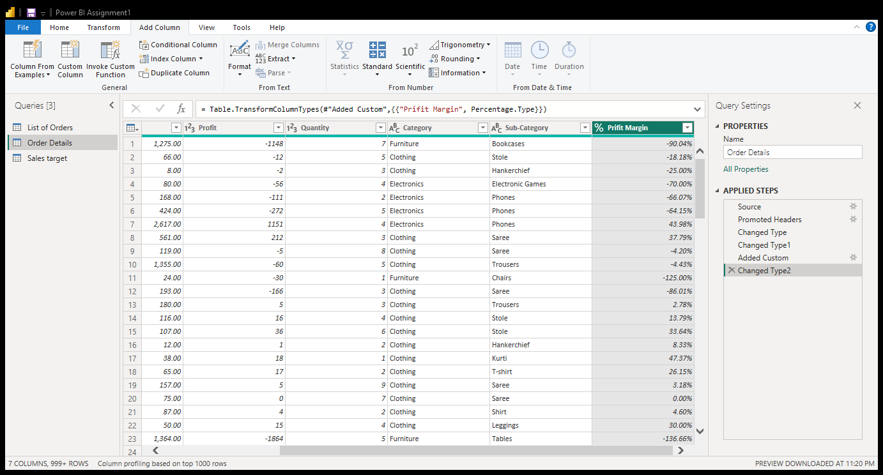
- Add a new conditional column named "Profit Status" based on the values in the "Profit" column. The conditions are as follows: if the profit is less than 0, the label should be "Loss"; if the profit equals 0, the label should be "Break-Even"; and if the profit is greater than 0, the label should be "Profit"
- Go to Add Column → Conditional Column.
- Enter Profit Status as the new column name.
- Set the conditions: if the profit is less than 0, the label should be "Loss"(profit<0=”LOSS”) elseif if the profit equals 0, the label should be "Break-Even"(PROFIT=0=Break-Even); and if the profit is greater than 0, the label should be "Profit"(profit>0=Profit)
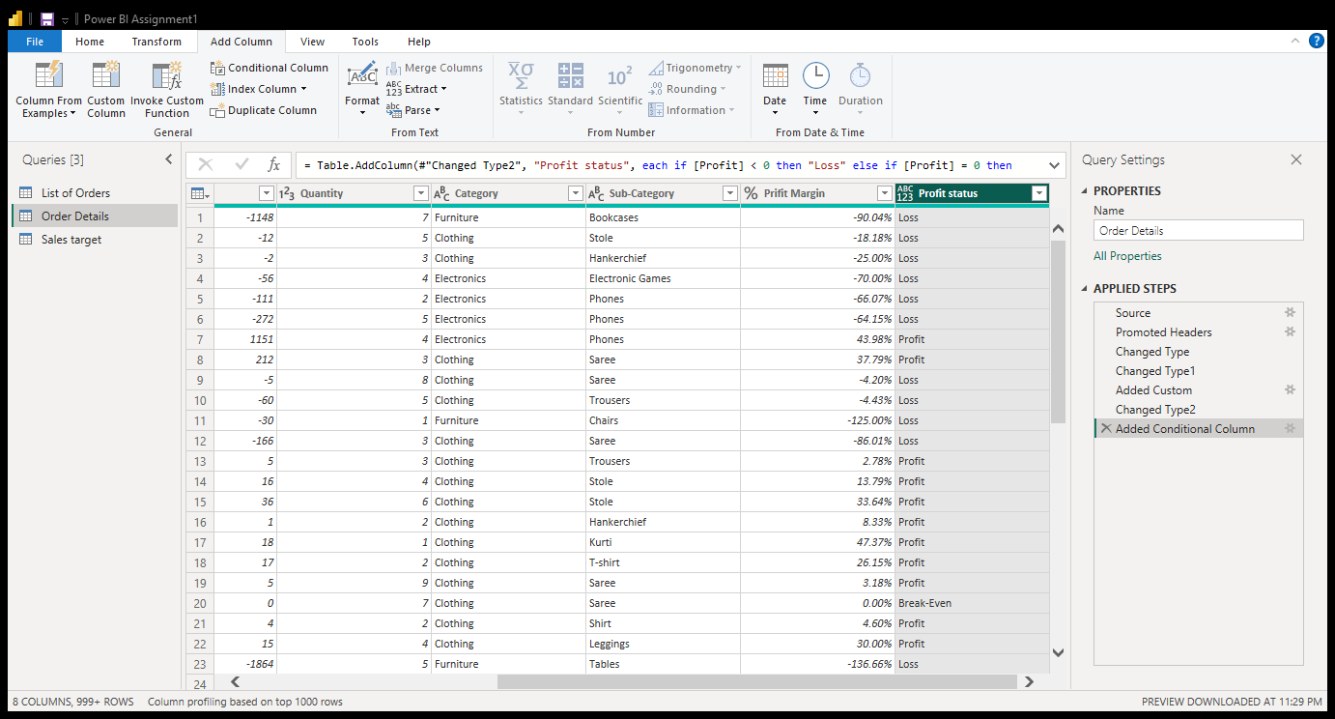

Merging Data (Joins):
- Merge the "List of Orders" and "Order Details" tables into a new single table named "Orders Data" based on the "Order ID" relationship.
- Go to Home → Merge Queries → Merge Queries as New.
- Select List of Orders as the first table.
- Select Order Details as the second table.
- Select the Order ID column in both tables.
- Choose Left Outer (all from first, matching from second) as the join type. Click OK.
- Rename the new merged table to Orders Data.

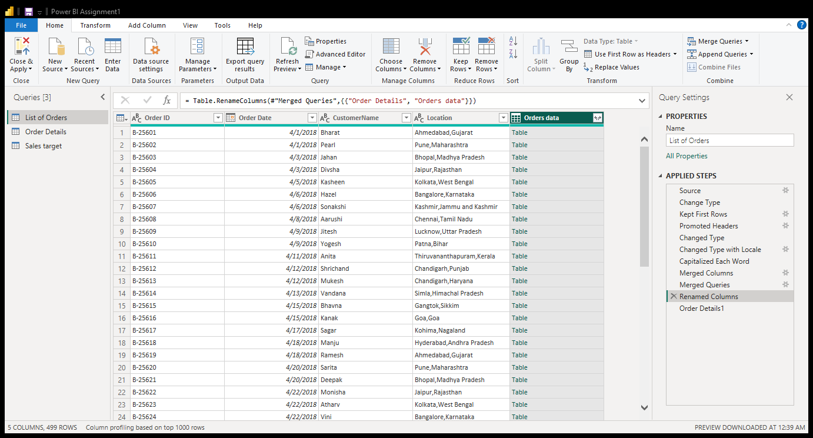
Pic:Merged tables

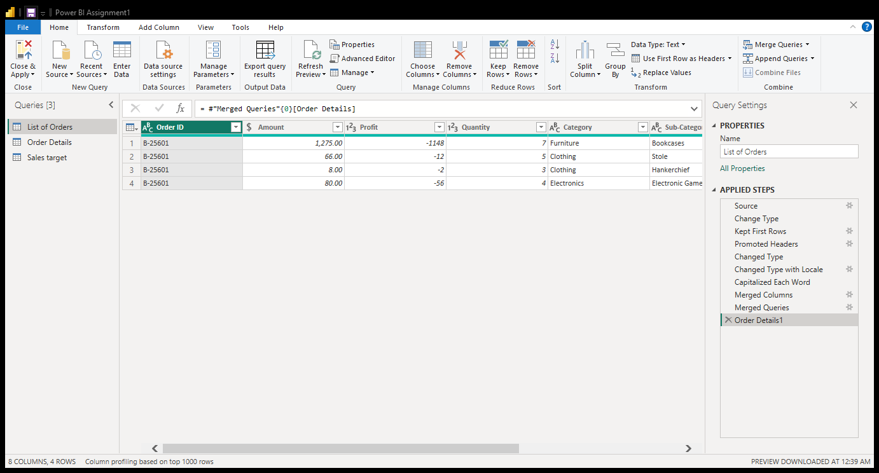
Pic: Table contents
Handling Missing Data & Duplicate Data:
- Missing values in the data and determine a strategy to address them.
- Select the column you want to check.
- Click the filter (▼) icon in the column header.
- Look for (null) in the list of values.
- Select (null) and click OK.
Now, only the rows containing null values will be displayed.
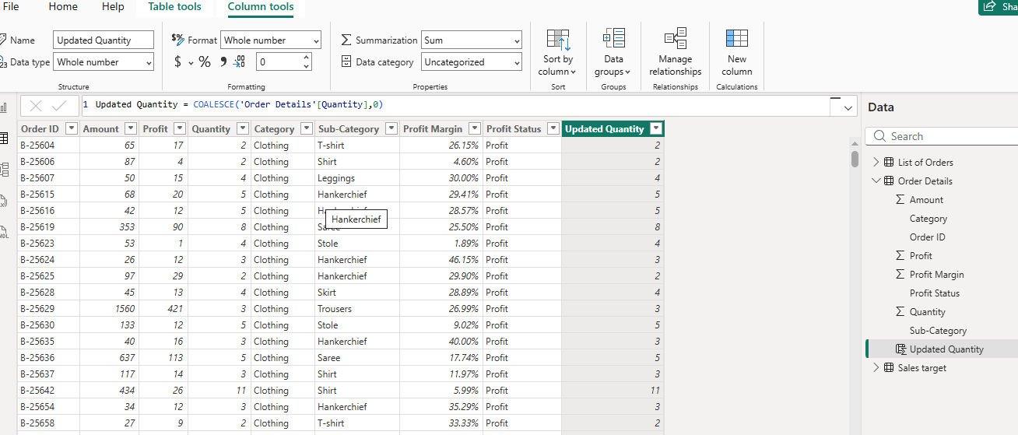
To handle missing values for proper visualization, we can use two methods. For numerical values, we can replace missing values with zero or the average value, depending on the data structure. In Power BI, the COALESCE function can be used to replace blank values with an appropriate value.You can right-click the column and choose Replace Values or remove the rows using Home → Remove Rows → Remove Blank Rows.When we use the Text values,we can put the particular value(Unknown,Not applicable).

- Check for duplicate rows and define a strategy to handle duplicates.
Duplicate Rows:
- Select the relevant columns or the entire table.
- Go to Home → Remove Rows → Remove Duplicates.
- Keep one copy of each duplicate record and remove the others.
Eg: Select Order Id column->Remove rows ->Remove duplicates
This ensures the data is complete, consistent, and free from unnecessary duplicate records. Identify duplicate records by checking the Order ID or other unique identifiers. If duplicate records contain the same information, keep one record and remove the duplicates using Home → Remove Rows → Remove Duplicates. This prevents duplicate data from affecting analysis and calculations.
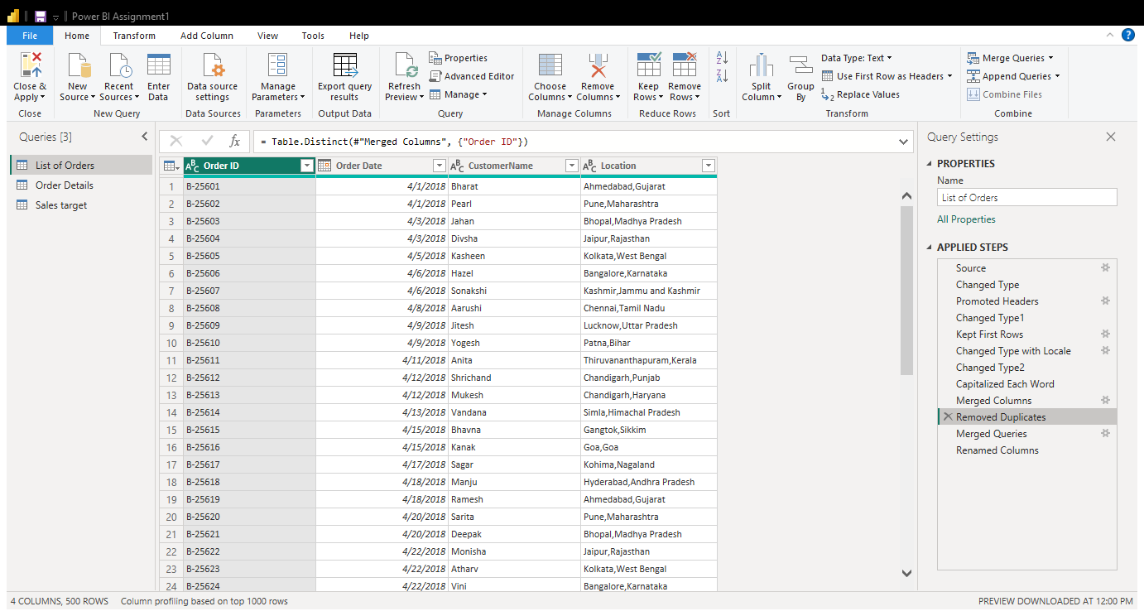

Sorting and Filtering Data:
In the ‘Orders Data’ table, utilize sorting and filtering techniques on columns like Order Date, State or Category to analyze data based on specific criteria:
- Sort the orders by Order Date in descending order to analyze recent trends.
Sort by Order Date: Select the Order Date column, click the filter arrow, and choose Sort Descending to display the most recent orders first and analyze recent trends.
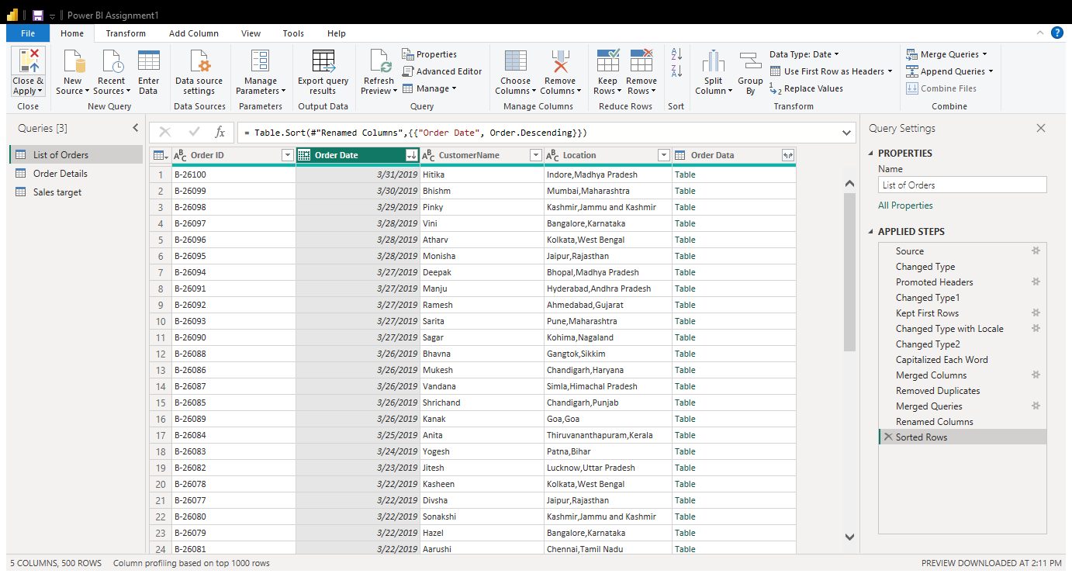

Pic :Sorted table

- Filter the orders to focus only on a specific state (e.g., Tamil Nadu) for regional analysis.
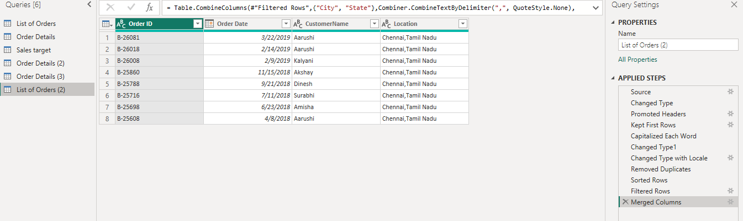
Filter by State: Select the State column, click the filter arrow, choose Tamil Nadu, and click OK to view only orders from Tamil Nadu for regional analysis.
Pic : Filtering table

Grouping and Aggregating Data:
Duplicate the Table: Right-click the “Order Details” table in the Queries and select Duplicate. Rename the duplicated table as required.
Count of Each Order ID: Select the Order ID column, go to Transform → Group By, choose Count Rows, and click OK to calculate the number of records for each Order ID.
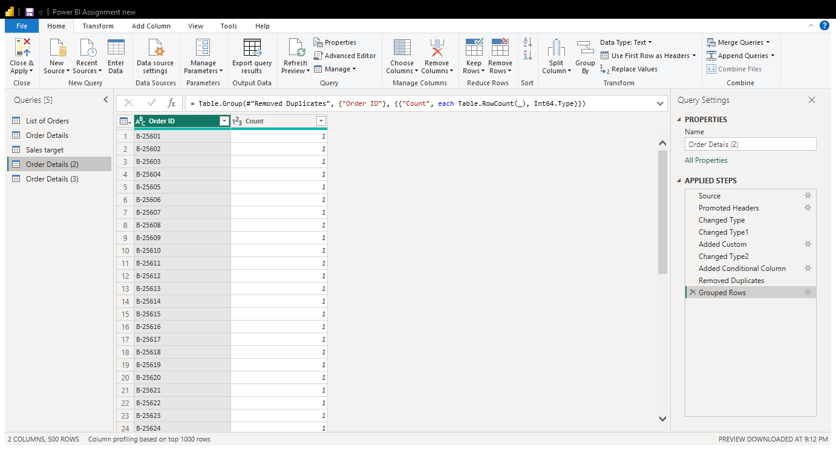
Pic: Duplicate the table “Order details” and count rows

Average Profit by Category: Select the Category column, choose Transform → Group By, select Average for the Profit column, and click OK.
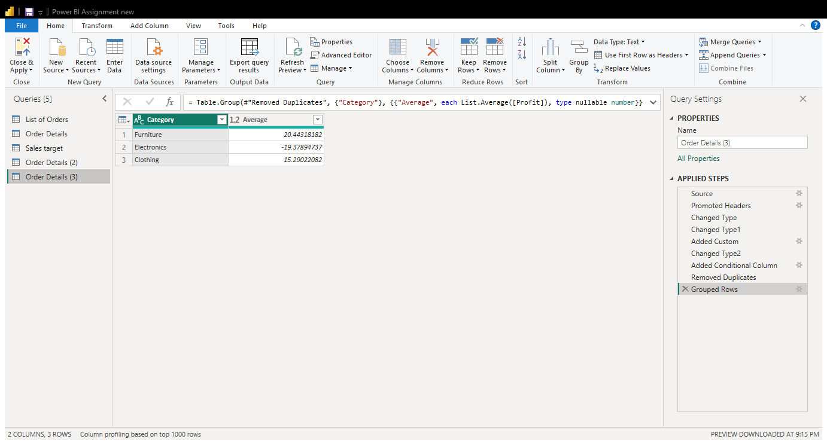
Pic: Average profit table
Total Amount by Sub-Category: Select the Sub-Category column, choose Transform → Group By, select Sum for the Amount column, and click OK.
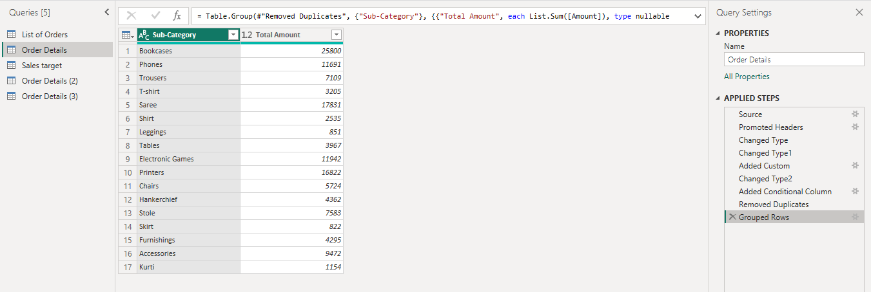
Pic:Total amount table

Duplicate the “Sales Target” table and aggregate the total target amount by Month of Order Date.
Right-click the Sales Target table.Select Duplicate. Rename the duplicated table if required. Select the Month of Order Date column and go to Transform → Group By. Choose Month of Order Date as the grouping column, select Sum as the operation, and choose the Target column. Name the new column Total Target Amount and click OK. This calculates the total target amount for each month of Order Date, allowing for further analysis.
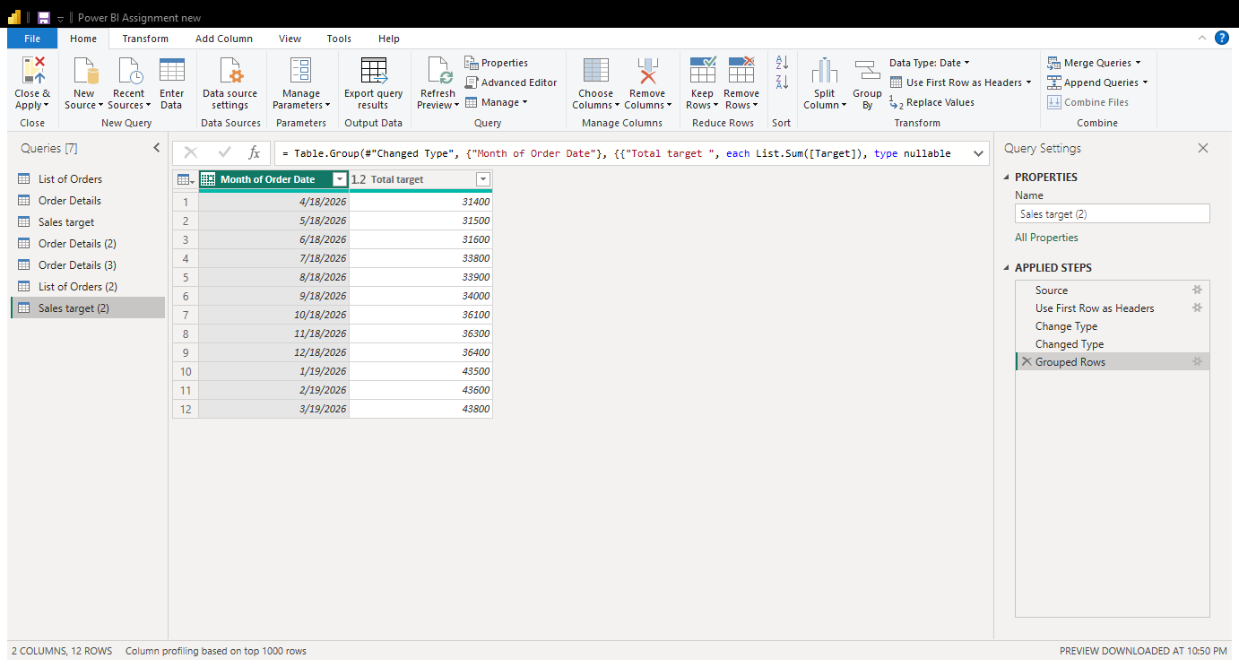
Pic :Total target amount by Month of Order Date

Data Modeling:
Duplicate the “Order Details” table and calculate the count of each Order ID, average profit by Category or total amount by Sub-Category.
In Power BI, go to the Model view and locate the List of Orders(1)_Data modeling data and Order Details(4)_data modeling data tables. Drag the Order ID column from the List of Orders table to the corresponding Order ID column in the Order Details table. In the relationship window, select the appropriate cardinality, usually One-to-Many (1:*), with List of Orders on the one side and Order Details on the many side. Set the cross-filter direction to Single and click OK.
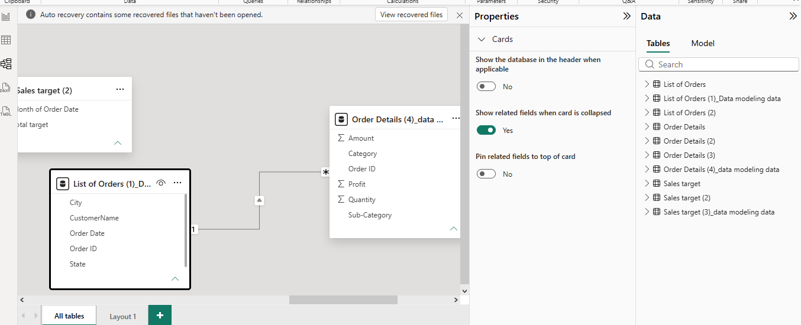
Pic: Data modeling

- Build a relationship between the “Order Details” and “Sales Target” tables based on the ‘Category’ column. Click "Manage relationships" and ensure this relationship is active.
Go to the Home tab and select Manage Relationships. Click New to create a relationship between the Order Details and Sales Target tables. Select the Category column in both tables, choose the appropriate cardinality and cross-filter direction, and ensure that the Make this relationship active option is selected. Finally, click OK and Close to establish the relationship.

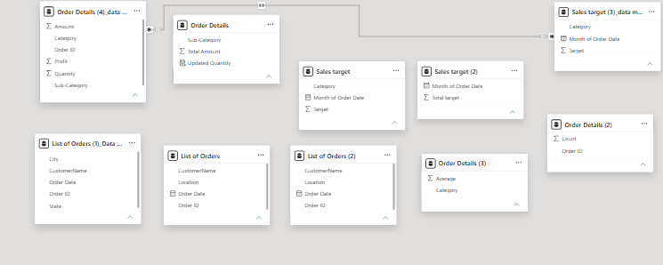

In Power BI, a relationship is created between the Order Details and Sales Target tables using the Category column. The relationship is activated through Manage Relationships, allowing data from both tables to be analyzed together.
Power BI is a business intelligence tool used to clean, transform, analyze, and visualize data. In this project, Power Query was used to clean data, handle missing values, remove duplicates, merge tables, and create new columns. Relationships were established between tables to support accurate analysis and create meaningful reports and dashboards.

